«${currentDate?date?string('dd MMMM yyyy'»
MyCCA reference: «${workflow.requestId}»

Agreement identifier: «${account.targetUnitIdentifier}» «${params.scheme}» Underlying Agreement «${params.version}»
Operator name: «${params.targetUnitDetails.name}»
Company number: «${(params.targetUnitDetails.companyRegis»
Address for service:
By post:
«${params.targetUnitDetails.location}»
Electronically:
«${params.targetUnitDetails.primaryContac»

CLIMATE CHANGE AGREEMENTS SCHEME

UNDERLYING AGREEMENT TERMINATED (ADMINISTRATIVE)
Dear «${params.targetUnitDetails.primaryContac»,

We are writing to inform «${params.targetUnitDetails.name}» ("you") that we terminated your underlying agreement to the Climate Change Agreements scheme on «${currentDate?date?string('dd MMMM yyyy'». This termination relates to the following agreement and include all the facilities listed within that agreement.

Agreement Identifier: | «${account.targetUnitIdentifier}» «${params.scheme}» Underlying Agreement «${params.version}»
We have proceeded with this termination because you notified us that are no longer carrying out an eligible activity in any of the facilities included in this agreement.
The termination of your agreement means that, from the date of this letter, you can no longer claim a discount on the Climate Change Levy for the energy supplied to the facilities in the agreement.
We will notify HMRC of this termination. It is your responsibility to notify your energy supplier(s) of this termination to ensure they apply the appropriate rate of Climate Change Levy on the fuels you use.
If you require any clarification of the above, please contact your Sector Association in the first instance.
If you need to contact the Administrator for any supporting information, please use the following email: cca-help@environment-agency.gov.uk.

Yours faithfully
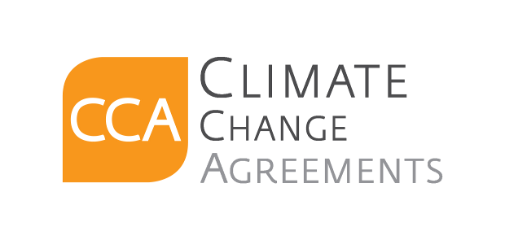
CCA Team

c.c. «[#list email.ccRecipients as cc]»«${cc}[#sep], [/#sep]»«[/#list]»

